For Sale 12+/- acres $160,000.00
All information is from sources deemed reliable, and is submitted subject to errors, omissions, change of price, terms, rental, prior sale, and withdrawal, buyer/tenants are encouraged to diligently review all aspects of the property


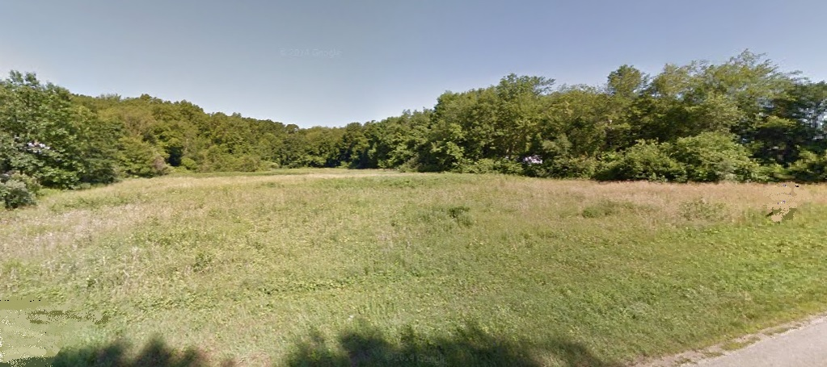
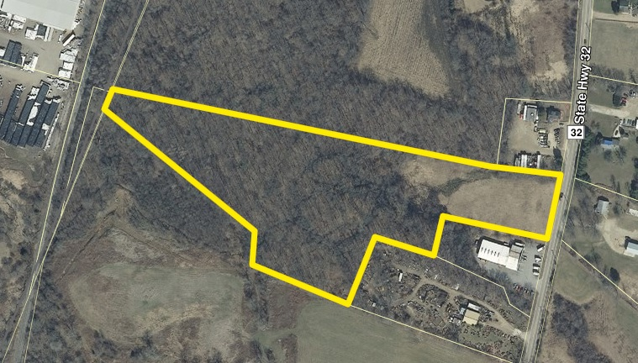

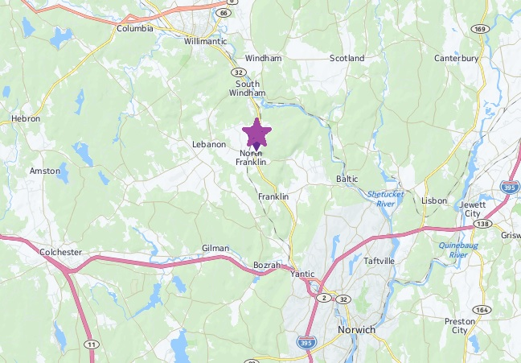
David Mieczynski
Office: 877-672-3847 ext. 1
cell: 860-234-7435
david@nradvisors.net
12+/- acres Commercial
Lot 9-6, Route 32, Franklin
Nice commercial land mostly wooded, some wetlands. Great visibility on Route 32. Excellent location for contractor, warehouse, office, etc.

Call your builder!
$160,00.00

